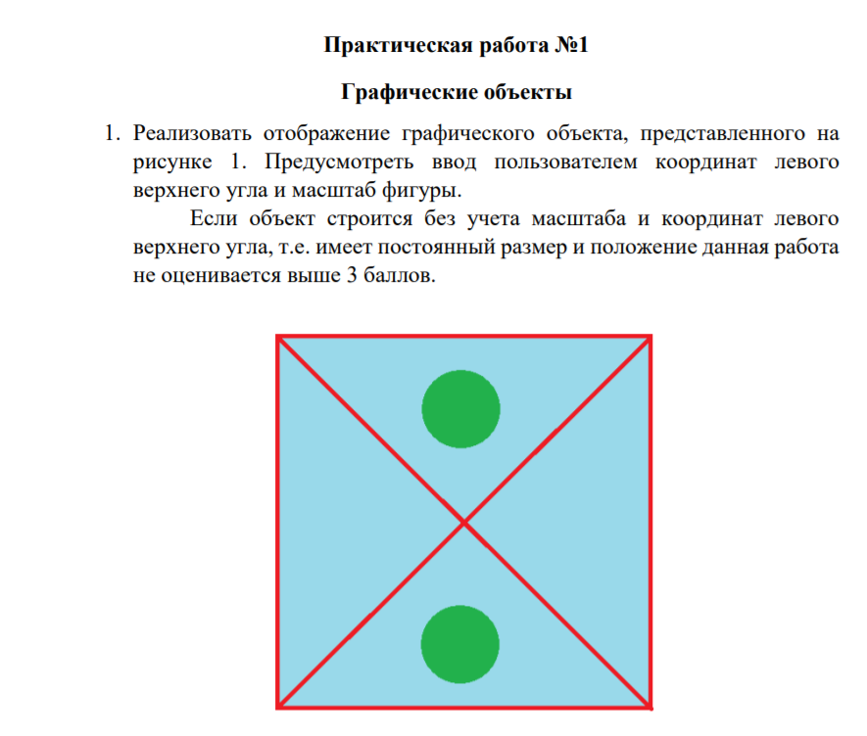

private void numericUpDown1_ValueChanged(object sender, EventArgs e)

{

pictureBox1.Image = new Bitmap(pictureBox1.Width, pictureBox1.Height);

Graphics g = Graphics.FromImage(pictureBox1.Image);

SolidBrush sb = new SolidBrush(Color.Blue);

Pen p = new Pen(Color.Red);

p.Width = 5;

g.FillRectangle(sb, 20, 20, Convert.ToInt32(numericUpDown1.Value) * 20, Convert.ToInt32(numericUpDown1.Value) * 20);

g.DrawRectangle(p, 20, 20, Convert.ToInt32(numericUpDown1.Value) * 20, Convert.ToInt32(numericUpDown1.Value) * 20);

Point p1 = new Point(20, 20);

Point p2 = new Point(20+(Convert.ToInt32(numericUpDown1.Value) * 20), 20 + (Convert.ToInt32(numericUpDown1.Value) * 20));

g.DrawLine(p, p1, p2);

Point p3 = new Point(20 + (Convert.ToInt32(numericUpDown1.Value)) * 20, 20);

Point p4 = new Point(20, 20 + (Convert.ToInt32(numericUpDown1.Value)) * 20);

g.DrawLine(p, p3, p4);

SolidBrush sb1 = new SolidBrush(Color.Green);

g.FillEllipse(sb1, 20 + (Convert.ToInt32(numericUpDown1.Value) * 8), 20 + (Convert.ToInt32(numericUpDown1.Value) * 2),

4*Convert.ToInt32(numericUpDown1.Value), 4*Convert.ToInt32(numericUpDown1.Value));

g.FillEllipse(sb1, 20 + (Convert.ToInt32(numericUpDown1.Value) *8), 20 + (Convert.ToInt32(numericUpDown1.Value) * 14),

4 * Convert.ToInt32(numericUpDown1.Value), 4 * Convert.ToInt32(numericUpDown1.Value));

}

private void Form1_Load(object sender, EventArgs e)

{

numericUpDown1.Value = 5;

}

